# CS 340 README Zachary Wright

## About the Project/Project Title

This project is for Grazioso Salvare through Global Rain regarding 5 non-profit animal shelters in the Austin, TX region. In this project, I was tasked with incorporating a dashboard for the database that was completed in the previous sprint (project one). This dashboard utilizes Jupyter Notebook and inherits all CRUD operations from the AnimalShelter class. This project, just like project one, will be an open-source project with source code hosted on GitHub so that anyone can use this application.

## Motivation

This project was made to build working knowledge on utilizing CRUD operations with databases and getting the return of visual data.

## Getting Started

To get started and run this application you will need to clone the repository or files from GitHub. From here you will open Jupyter Notebook in the same location that was used for project one; please note that even though the project one dashboard file will not be used here, you will need to use the CRUD class in animal_shelter.py to successfully run project two dashboard. Once the files are imported into your you can connect to the database that was created in the last project that contains the .csv file. The files needed to reproduce the dashboard are animal_shelter.py and ProjectTwoDashboard.ipynb; to connect to this database run the appropriate commands in MongoDB to start up mongo shell in port 36808. Once your environment is set up and you have connected to p[ort 36808 you can begin to run the Jupyter Notebook file and start interacting with the dashboard.

## Installation

To run this application, you will need to download MongoDB and Python3 or you can use the SNHU Virtual Lab if you have access to it.

## Usage

Usage of this application can be for practice of using CRUD classes to return interactive data in a dashboard format or retrieval of specific data about animals in shelters in Austin, TX area.

### Code Example

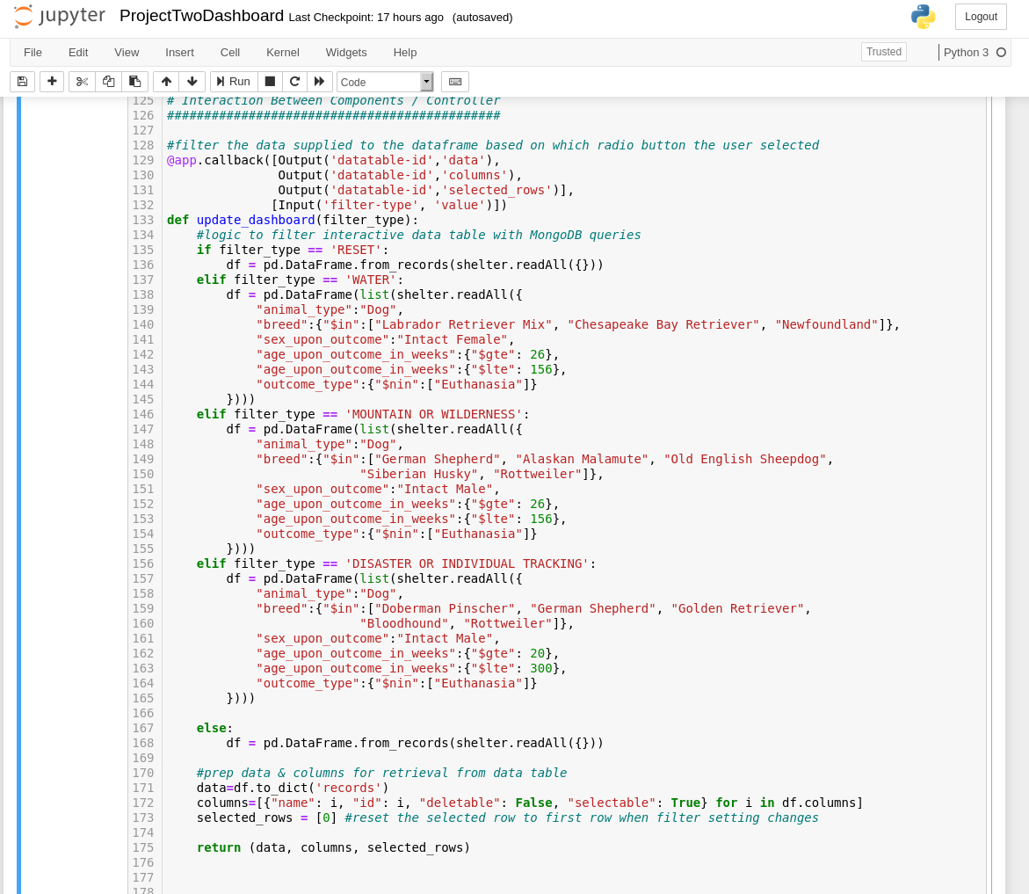

### Tests

My test checks all CRUD methods from animal_shlter.py. The tests include creating, reading, updating, and deleting an instance, where instance refers to objects of data in the database. These tests were incorporated in Project one and no further testing has been added.

### Screenshots

Dashboard overview: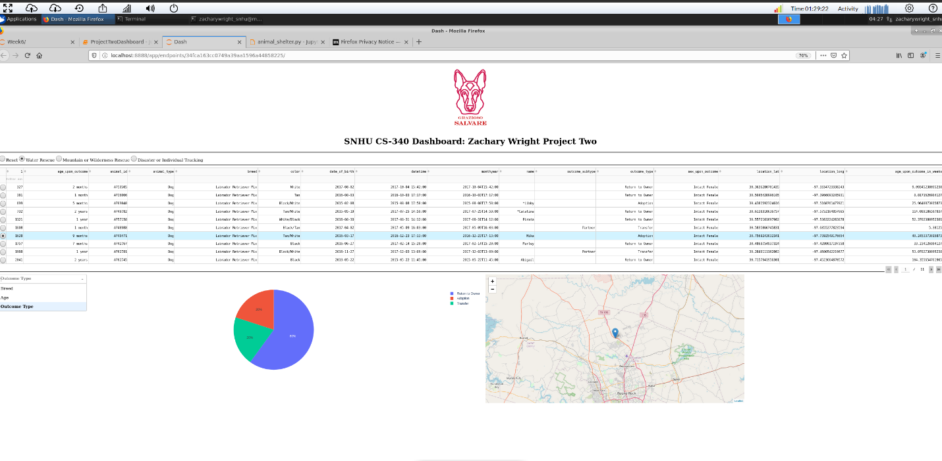

## Contact

Zachary Wright, Zachary.wright2@snhu.edu